ISLAMIC UNIVERSITY OF TECHNOLOGY

Organization of Islamic Cooperation

Board Bazar, Gazipur

Laboratory Report

CSE 4512

**Title**: Configuring and Verifying of RIP in a network topology.

**Objective**:

* Describe the concept of dynamic routing
* Explain disadvantages of RIPv1 and improvement in RIPv2
* Configure Routing Information Protocol (RIP) in a network topology following given specifications

**Devices/Software Used**: Cisco Packet Tracer

**Theory**:

Distance Vector (DV) Routing

The Distance Vector Routing method is an intra-domain routing protocol that uses the Bellman-Ford algorithm to calculate the shortest path between two nodes. Under this protocol, routers share their entire routing table with their immediate neighbours every 30 seconds. This results in a ripple effect that eventually reaches the entire network. The higher convergence time is offset by the benefit of lower overall network traffic.

When a router receives an update from a neighbour, it compares the entries with the entries in its existing routing table and replaces any entries for which the neighbour provides a lower cost. The comparison step is where the Bellman-Ford algorithm is used.

Count to Infinity problem in DV routing

The Count-to-Infinity problem occurs when one router, router A, loses a connection to a network, network X, but does not immediately notify its neighbours. Soon after, some neighbour, say router B, will send an update to router A advertising that the network X can be reached with some cost. However, this is erroneous data, since router B is under the impression that network X can be reached via router A.

Router A updates its routing table with this information, increasing the cost, since it must travel via router B. This leads to router B updating its routing table, which causes router A to also update its routing table and so on. The loop eventually causes both routers to keep increasing the cost of reaching network X to infinity.

Two node Loop problem in DV routing

The Two-Node Loop problem is the same as the Count-to-Infinity problem.

Split Horizon (one solution to instability)

Split Horizon is one method to solve the Count-to-Infinity problem. It says that a router, while sending updates to a neighbour, should remove the entries for which the neighbour itself is the next hop. For example, if router A has entries in its routing table for which router B is the next hop, those entries will be removed from the update being sent to router B.

In the example for the Count-to-Infinity problem given above, this will result in router B not sending the erroneous update to router A in the first place. Thus, router A's routing table will continue to show that network X cannot be reached, and when router A eventually sends an update to router B, router B's routing table will be corrected, albeit somewhat late.

Poison Reverse

Poison Reverse is another solution to the Count-to-Infinity problem. It is the same as the Split Horizon solution, except that instead of simply not sending entries for which the neighbour itself is the next hop, the entries are advertised with an infinite cost.

Under the Split Horizon solution, for the example given above, router A would not know that router B is not sending it information about network X because router B's information comes from router A itself. It might be the case that router B genuinely does not have information about network X. Under the Poison Reverse solution, router A would become aware that the information that router B has about network X comes from router A itself, which is why it is advertising an infinite cost.

Routing Information Protocol (RIP)

The Routing Information Protocol is the most famous protocol that uses the Distance Vector Routing method. There are no changes to the basic mechanism of how it works. However, RIP is quite old and is not used on the modern internet. There are two versions, RIPv1 and RIPv2, and in the few cases where RIP is used, it is almost certainly RIPv2.

Forwarding Table used in RIP

A Routing Table is a table maintained in every router. It contains a list of networks, where to forward packets to reach those networks, and the cost of using that path. In RIP, each router forwards this table to its neighbours so that the neighbours can compare the data with their existing routing tables and replace any entries for which this router provides a path with a lower cost.

Hop Count as cost

RIP uses Hop Count as the cost. This means that when a router advertises its routing table to neighbouring routers, the cost it advertises refers to the number of hops required to reach a device on the destination network from this router.

Timers in RIP

RIP uses three timers.

The first is the periodic timer. This is used to send updates about the routing table to neighbour routers every 30 seconds.

The second is the expiration timer. Every entry in the routing table has its own expiration timer. If the router does not receive updates about an entry for 180 seconds, the entry is considered invalid.

The third is the garbage collection timer. When an entry becomes invalid, this timer is started for that entry. If an update is not received within 120 seconds, the invalid entry is removed from the routing table.

**Diagram of the experiment**:

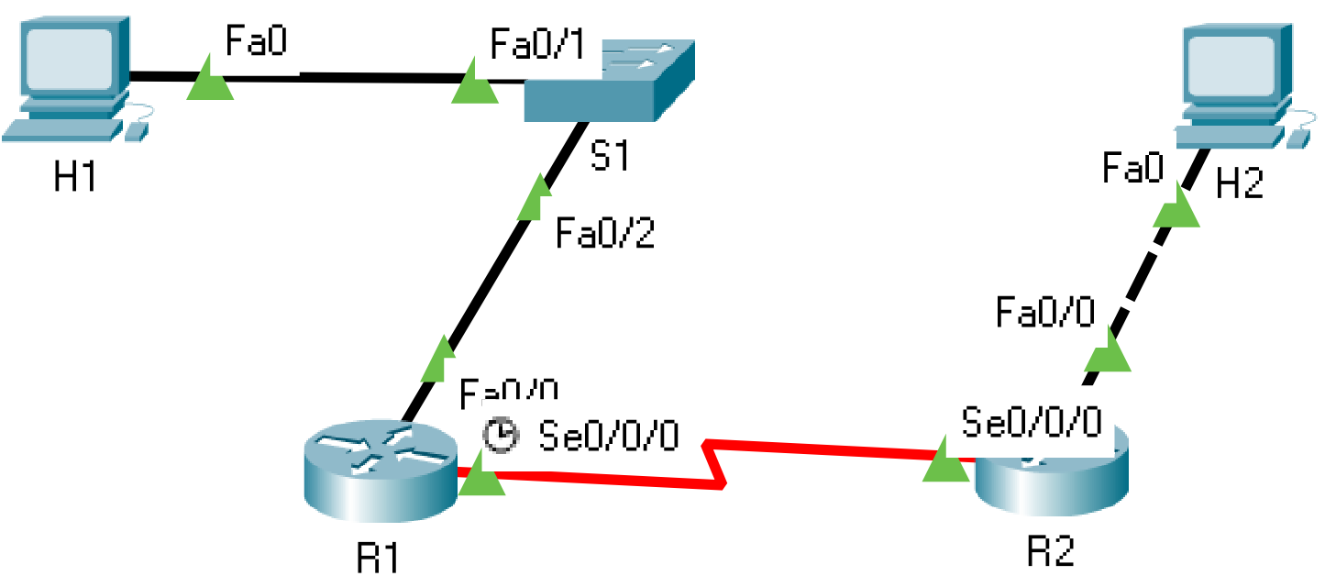

**Working Procedure**:

1. The network topology shown in the diagram above was built.
2. The hostnames and interfaces for routers R1 and R2 were configured based on the provided chart.

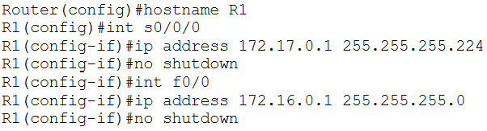

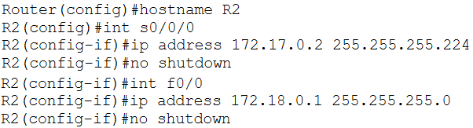

1. The two host devices were configured with the provided details:

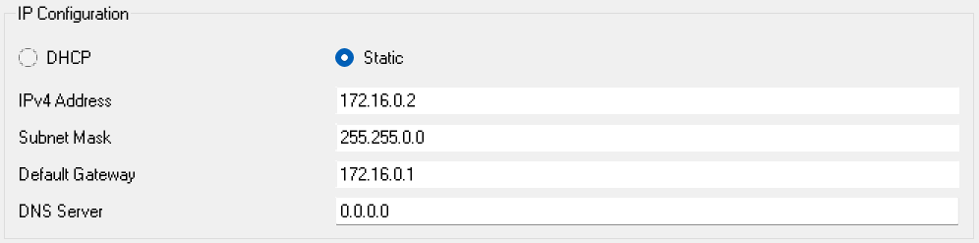

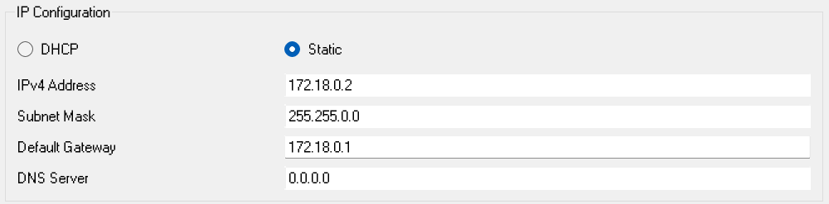

1. The IP routing table of R1 was viewed.

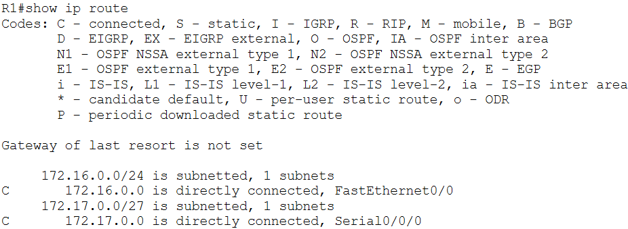

1. Pings are done from R1 to ethernet interface of R2 and from H1 to H2.

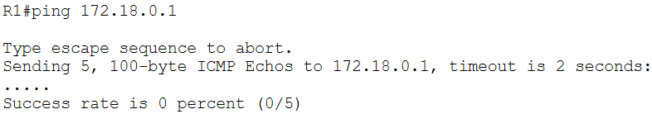

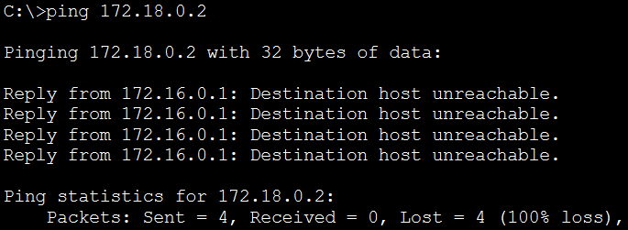

1. The routing protocols for both routers were configured.

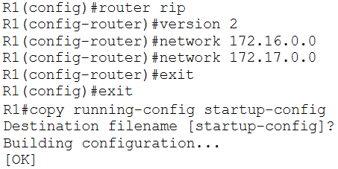

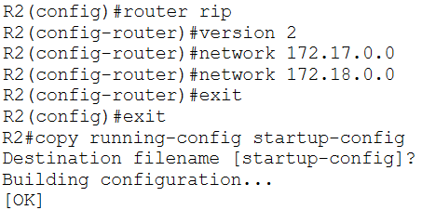

1. The routing tables of each router were viewed.

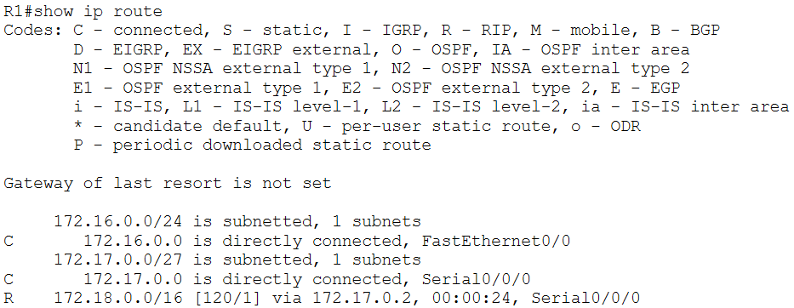

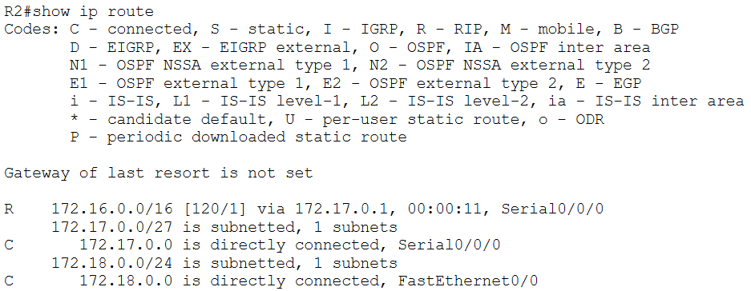

1. Pings were done from R1 to the fast ethernet interface of R2 and from H1 to H2.

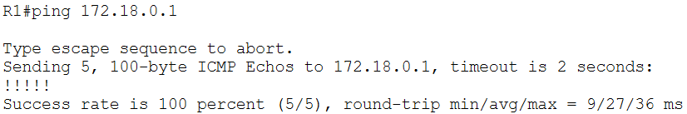

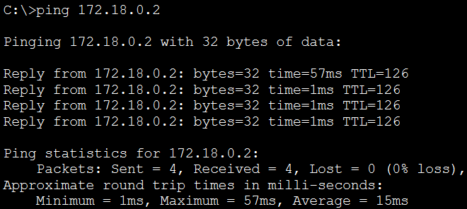

1. Debug was used to observe RIP communications from R1.

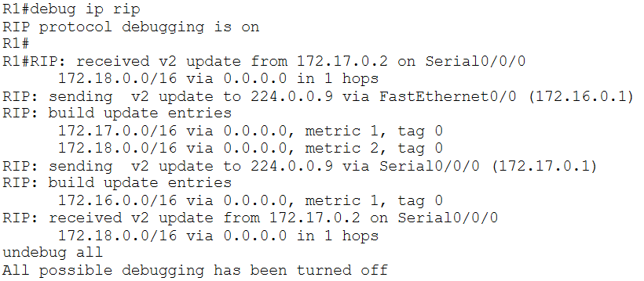

**Observation**:

Step 3:

b. The ‘C’ signifies that the specified route is directly connected to the interface.

c. There is no route in R1 to the R2 ethernet network. This is because the route has not yet been added statically or dynamically. Routers do not automatically become aware of the networks connected to their neighbouring routers.

Step 4:

b. The pings are not successful.

c. The pings are not successful.

d. The pings were not successful because R1 is unaware of the network connected to the ethernet interface of R2. This results in H1, which is connected to R1, being unable to ping H2, which is connected to R2.

Step 6:

b. The network connected to R1’s fast ethernet interface, the network connected to R1’s serial interface and the network connected to R2’s fast ethernet interface are shown.

c. The ‘R’ signifies that the network is connected via RIP.

d. 172.17.0.2 is the IP address of the Serial0/0/0 interface of R2. ‘via 172.17.0.2’ means that the network can be reached by using this address as the next hop.

e. ‘Serial0/0/0’ indicates that that interface should be used to reach the specified network.

g. The network connected to R2’s fast ethernet interface, the network connected to R2’s serial interface and the network connected to R1’s fast ethernet interface are shown.

Step 7:

a. The pings are successful.

b. The pings are successful.

c. Both pings were successful because R1 is now aware of the existence of the network connected to the fast ethernet interface of R2. By extension, H1, which is connected to R1, can ping H2, which is connected to R2.

Step 8:

c. R1 receives updates via the Serial0/0/0 interface. It sends updates through the Serial0/0/0 interface as well as the FastEthernet0/0 interface, even though the latter is not connected to a router.

d. The metric used in RIP counts hops. The route 172.17.0.0 has a metric of 1 because that network is directly connected to the Serial0/0/0 interface of R1. This means any device on that network can be reached within 1 hop. The route 172.18.0.0 has a metric of 2 because that network is connected to the FastEthernet0/0 interface of R2, which is 1 hop away from R1. This means any device on that network can be reached within 2 hops.

Step 9:

a. The routing table entry for that network would remain the same for 180 seconds, at which point the expiration timer would expire. The entry would then be assumed to be invalid. However, the entry would not be removed, it would just not be used. Once the expiration timer has expired, the garbage collection timer would be started, which lasts for another 120 seconds. Once this timer has expired, the invalid entry would be removed.

b. Both routers would continue to send out routing table updates using the RIP version they are configured with. However, they would not receive updates that use the different RIP version. Due to the way this network is set up, this would mean that communication between the network connected to the ethernet interface of R1 and the network connected to the ethernet interface of R2 would stop. [Reference](https://community.cisco.com/t5/routing/mix-of-rip-ver-1-and-ver-2-in-network/m-p/2344621/highlight/true#M225014)

**Challenges**:

There was only a minor challenge in the step where the debug command was used. It took a while to figure out the output for this command and conclude that there was nothing wrong with it.